Design and Technologies Glossary
A
aerial view  Drawing from above (in the air) to show features of a building, landscape or environment e.g. the image shows an aerial view of a garden plan. | 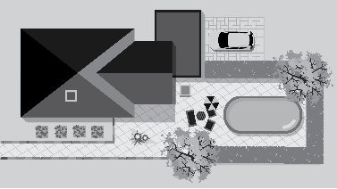
aesthetics
Judgements based on sentiment and the visual impact or appeal of a product or environment and are influenced by social, emotional and demographic factors.
Asia/Asian
Geographically, the largest continent, bounded by Europe and the Pacific, Arctic and Indian oceans. It can be described in cultural, religious, historical and language boundaries or commonalities.
B
backcasting
A process that starts with defining a desirable future and then working backwards to identify policies and programs that will connect the future to the present.
biomimicry
Inspiration for features and functions found in nature for use and adaptation in the design of a product, service or environment, e.g. Velcro fastening and air vents were inspired by nature.
bunraku puppet
The traditional Japanese form of puppet theatre in which half-life-size dolls act out a chanted, dramatic narrative using forces and motion.
C
characteristics
Distinguishing aspects (including attributes and behaviours) of an object, material, living thing, system or event. These qualities influence the choices people make about materials and processes.
construction play
Manipulating elements of materials or objects to create something new, such as modelling, stacking, sorting, drawing and disassembling.
Country/Place
Spaces mapped out that individuals or groups of First Nations Peoples of Australia occupy and regard as their own and having varying degrees of spirituality. They include lands, waters and sky.
crop sensors
Physical or remotely operated sensors that measure and record data about food or fibre crops and give real-time measurements of physiological factors such as nutrient status and moisture.
D
danger-zone temperatures
The temperature range between 5° Celsius and 60° Celsius is known as the danger zone and within this temperature range bacteria that cause food poisoning can multiply quickly to unsafe levels.
data
A general term for a set of observations or measurements collected during an investigation. Primary data is collected by the user; secondary data is collected by others.
design brief
A statement clarifying a project task and defining the need or opportunity to be resolved. It usually identifies the users, design criteria, constraints, resources and timeframe.
design criteria
Criteria used to determine if the proposed solution meets the requirements. They are drawn from the solutions requirements, user stories, if appropriate, and constraints.
design process
A process that involves investigating and defining; generating and designing; producing and implementing; evaluating; and collaborating and managing to create designed solutions that meet needs.
design thinking
An approach which helps people to empathise and understand needs, opportunities and problems; generate, iterate and represent innovative, user-centred ideas; and analyse and evaluate those ideas.
designed solutions
The products, services or environments that have been created for a specific purpose or intention as a result of design thinking, design processes and production processes.
digital tools
Digital hardware, software, platforms and resources used to develop and communicate learning, ideas and information, e.g. software and hardware to compose and record music.

divergent techniques
Tools or approaches to support design thinking, in particular the generation of design ideas, e.g. brainstorming and role-play techniques are unstructured and encourage creativity.
drawing standards
Australian standards for technical drawing. Identified as Australian Standard AS 1100, they describe the drawing conventions for professionals and associated tradespeople.
E
electronic planting calendar
An online or software-based month-by-month guide of suitable crops to plant and typical garden maintenance tasks which need to be done, e.g. a database or simple table.
empathy
The ability to understand and share the feelings of another person.
enterprise skills
Abilities and dispositions to generate and apply new ideas to practical situations, including identifying new opportunities for change, risk management and following through on initiatives.
environments
One of the outputs of technologies processes or a place or space in which technologies processes operate. Environments may be natural, managed, constructed or digital.
exploded view  An image of an object with individual parts shown separately but arranged to show the relationship and position of the parts for assembly. | 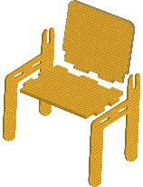
F
features
Distinctive properties, characteristics, functions and qualities of an object, material, living thing, system or event that affect how it performs or operates.
fibre
Plant-based materials (e.g. cotton, bamboo, timber and hemp) or animal-based materials (e.g. wool and silk) that can be used for clothing or construction.
food and fibre production
The process of producing food and fibre as natural materials for the design and development of a range of products.
forecasting
The process of predicting the future based on current trend analysis and using historical data to determine the direction of future trends.
functionality
Design of products, services or environments to ensure they are fit for purpose and meet the intended need or market opportunity and identified design criteria.
G
graphic visualisation software
Software that supports dynamic views of design ideas and designed solutions. Users of the software can change the behaviours, views or results of the designs by providing different inputs.
graphical representation techniques
Techniques used to communicate ideas and plans, e.g. making patterns and technical drawing. The graphical representation techniques for each year and band are included in the band description.

H
hardwood
The wood from broadleaved or angiosperm trees such as oak, ash, gum, jarrah.
I
J
jig
A custom-made tool or piece of equipment used to control the positioning and or motion of another tool to go into a work piece. Examples are woodworking jigs such as a dowelling jig and welder's jigs.
K
L
life cycle thinking
A strategy to identify possible improvements to products, services and environments to reduce environmental impact and resource consumption while considering social and economic impacts.
M
managed environments
Environments controlled by humans, e.g. farms, forests, marine parks, waterways, wetlands and storage facilities.
minimum-tillage cropping
Methods of ploughing which provide minimum disruption to the soil, thus allowing soil to maintain its natural structure. Minimum tillage requires the use of specially designed machinery.
model
A visual or physical representation that describes, simplifies, clarifies or gives an explanation of the workings, structure or relationships within an object, system or idea.
N
O
orthogonal drawing  A scaled multiview drawing of a 3-dimensional object to show each view separately, in a series of 2-dimensional drawings. | 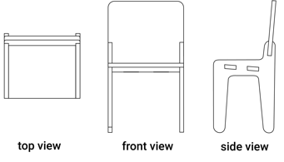
P
paddock- to- plate
All the steps in the growing, production, processing, transportation, retail and preparation of food. A similar phrase is farm to fork.
passive design
A design approach that uses natural elements – often sunlight – to heat, cool or light a building. Systems that employ passive design reduce or minimise the need for auxiliary heating or cooling.
personal protective equipment (PPE)
Equipment used or worn by a person to minimise risk to the person’s health or safety, e.g. safety goggles, ear muffs, face shield, hard hat, apron, gloves.
perspective drawing  A drawing that represents the way objects appear to be smaller and closer together, the further away they are. Perspective drawings show 3 different spatial viewpoints. | 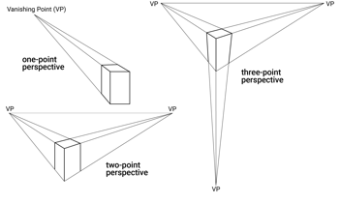
pictorial and aerial views  Drawings or maps showing objects from different angles, e.g. pictorial views are 3-dimensional on a 2-dimensional surface, and aerial views are drawings from a height or a wide angle. | 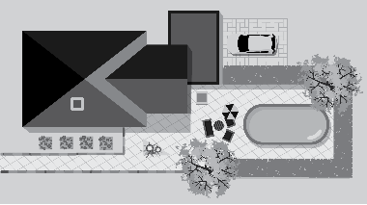
pictorial map
A map that uses illustrations rather than conventional cartographic symbols. Often the area shown is viewed from above or on an oblique angle. Pictorial maps are not drawn to scale.
plan view
A top view or a view as seen from above. Objects or places can be looked at from different points of view including front, side and plan views. An orthogonal drawing view.
play
Any activity that is positively valued, self-motivated, freely chosen and engaging.
preferred futures
Preferences for the future identified by a student to inform the creation and evaluation of solutions. This entails students considering how the solutions they create now may be used in the future.
preparing soil
The processes of tillage, addition of organic matter and fertilisers, and drainage before establishing a food or fibre crop.
production drawings
Working drawings that detail the requirements for the manufacture and assembly of products and environments.
production processes
The technologies context–specific processes used to transform technologies into products, services or environments, e.g. the steps used for producing a product.
products
The tangible end results of natural, human, mechanical, manufacturing, electronic or digital processes and production to meet a need or want.
project management
Detailed proposals for managing projects so they can meet the design criteria, e.g. plans usually list and sequence tasks, and indicate the required resources, costs and timelines.
properties
Distinctive qualities of a material that can be tested and used to help people select the most suitable one for a specific use, e.g. absorption, corrosion, insulation, opaqueness and sensory.
Q
R
rapid prototyping
A range of techniques used to quickly fabricate a scale model of a physical part or assembly using 3-dimensional computer-aided drawing. Construction of the scale model can be done using 3D printing.
rendered
A drawing that shows the relative relationship of elements or the form of objects using texture, colour, light, shade and tone (lightness or darkness of a colour).
resources
Assets available to assist in meeting needs or opportunities including energy, time, finance and human input.
S
sensory properties
Attributes used to evaluate and describe foods on the basis of senses. They include taste, aroma, texture or mouthfeel, appearance and noise. Each relates to a sense and can impact food choices.
services
The less tangible outcomes of technologies processes (compared with products). They may involve the development or maintenance of a system such as catering and water management.
side view
Drawing of an object to show what it looks like when viewed from its side. An orthogonal drawing view.
T
technologies contexts
The focus and opportunities for students to use a broad range of processes and production skills to design and produce products, services and environments. Contexts are prescribed for Years 1 to 8.
thumbnail sketches
Quickly developed outlines or small representations of objects and ideas to inform development of designed solutions.
top view
Drawing of an object to show what it looks like when viewed from above. An orthagonal drawing view.
traditional owners
The original owners of a particular region based on their traditional and cultural associations with the land and who have ongoing traditional and cultural connections to that Country/Place.
U
V
W
working models
Physical prototypes or virtual engineering simulations that can be used to evaluate performance and test how components interact.
X
Y
Z

